Patty’s Meatloaf Recipe
Prep: 15 minutes
Cook time: 1- 1 ½ hours
Serves: 8 slices
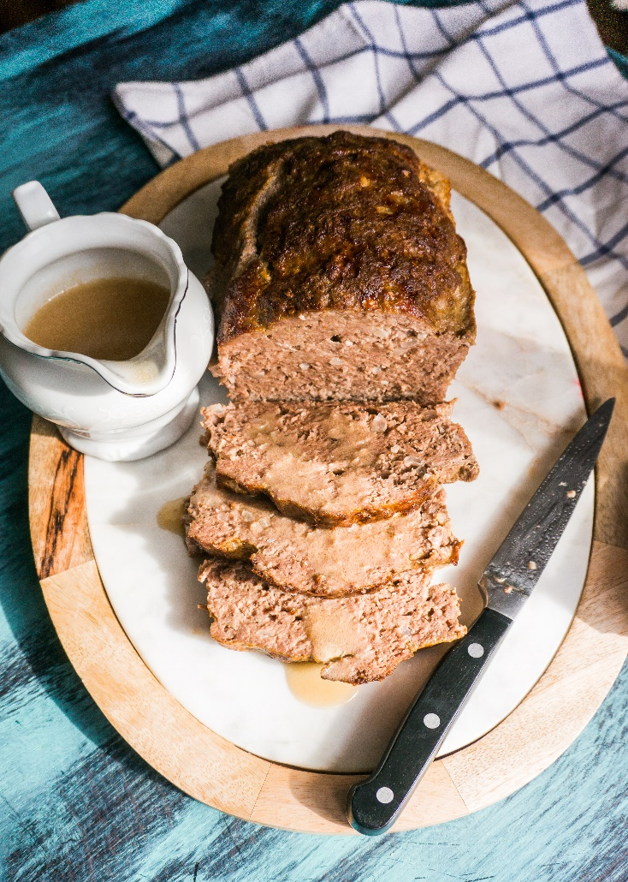
Ingredients:

For the Meatloaf:
1.5 lb lean ground beef
1 lb ground pork
1 medium onion, chopped
5 cloves garlic, minced
2 eggs
1/4 cup flour
1 tbsp soy sauce
1 tbsp fish sauce (patis)
1 tsp garlic powder
1 tsp salt
1/4 tsp ground pepper
For the Sauce:
Reserved drippings from cooked meatloaf
1/2 cup beef broth
2 tbsp flour
2 tbsp 35% cream
1 tbsp balsamic vinegar
salt and pepper, to taste
1 tbsp chopped fresh parsley (optional)

Directions:
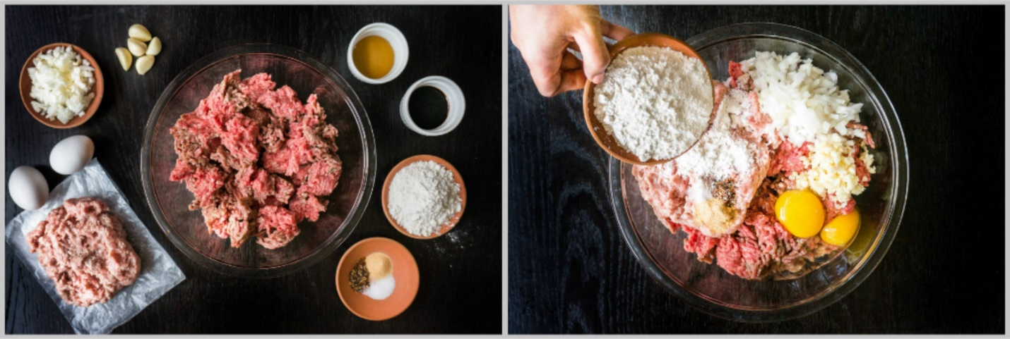
1. Pre-heat oven to 375F.
2. Mix all meatloaf ingredients until fully combined.Place meat mixture into a 9"x5" metal or glass oven proof baking dish. Cover dish with foil.
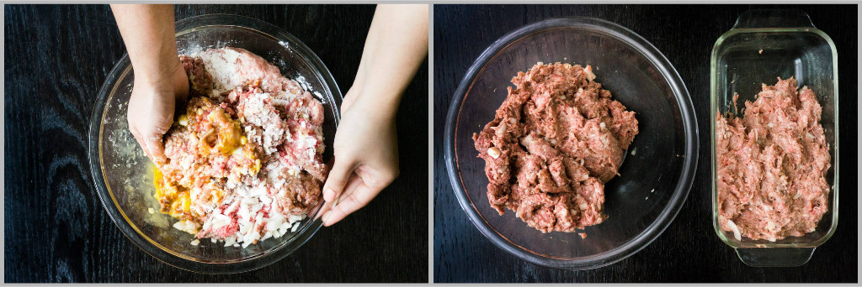

3. Place in the oven and bake for 1 hour. Remove foil cover and increase oven temperature to 400F and continue baking for another 20-30 minutes, or until top is golden brown and meat thermometer reaches 165F.
4. Once fully cooked, remove from oven and using oven mitts, gently drain fat and drippings from pan into a small sauce pot.
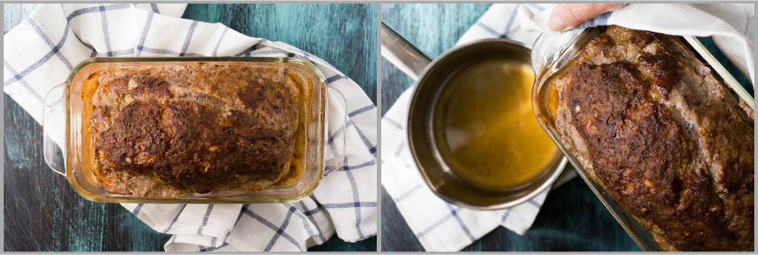
5. Whisk into pan drippings the flour and place pot on the stove over medium heat, and cook for 1-2 minutes.
6. While whisking, add the 35% cream and balsamic vinegar. Continue whisking, then slowly add the beef broth.
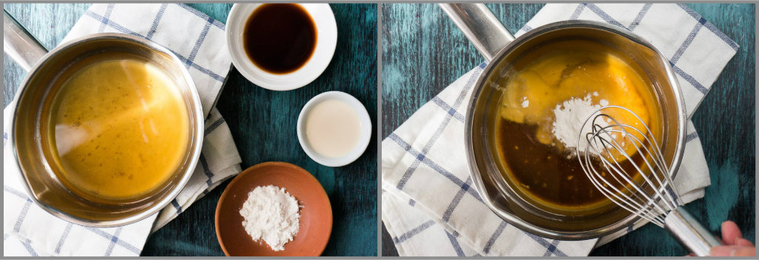
7. Bring mixture to a boil, then simmer for 3-5 minutes until mixture has thickened slightly. Season with salt and pepper to taste. Remove from heat, and add in chopped parsley, if using. Serve with meatloaf slices.

Enjoy!
